**Task 1 Introduction Version Control System (Git)**

* Practice on the following commands:
  + Git clone
  + Git init
  + Git diff
  + Git status
  + Git add .  & Git add filename
  + Git log
  + Git commit -m “message here”
  + Git push
  + Git pull
  + Git reset
  + Git config --global username “username here”
  + Git config --global user. Email “email here

Git Clone

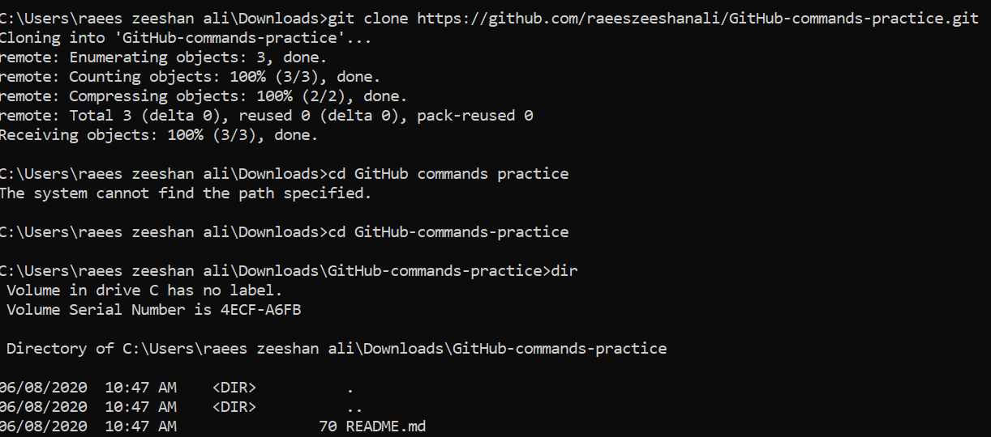

Git init

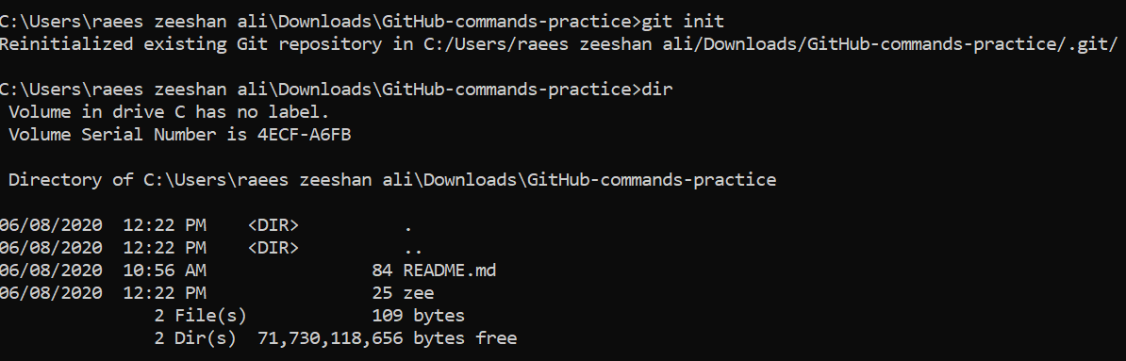

Git diff

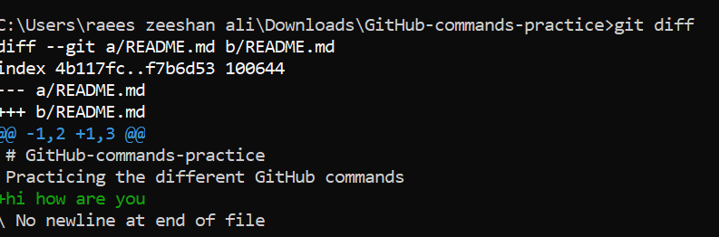

Git status

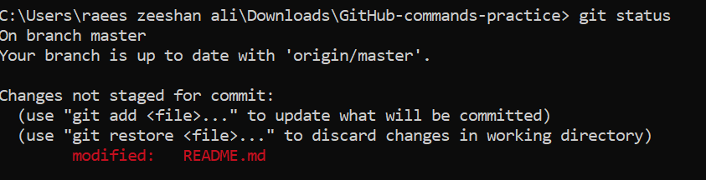

Git add

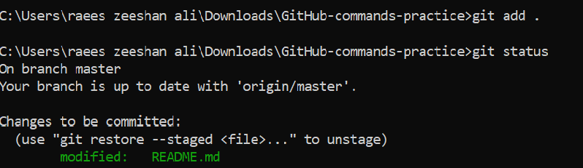

Git log

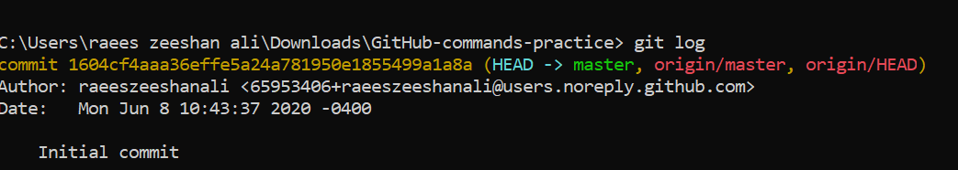

Git commit

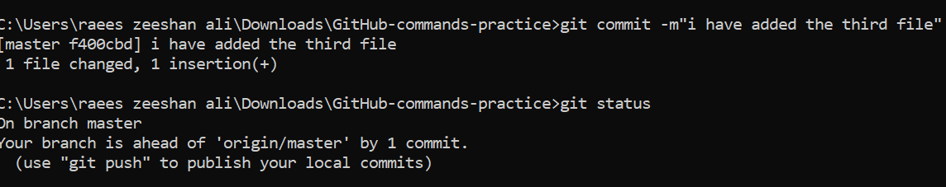

Git push

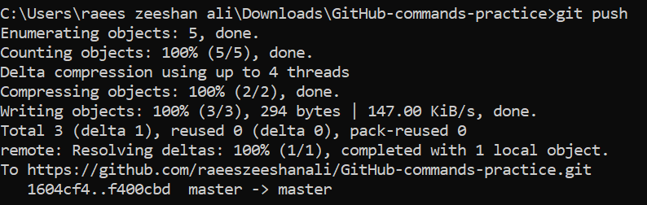

Git pull

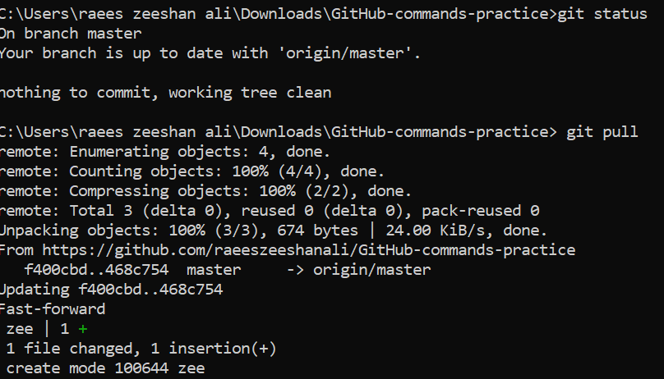

Git config



TASK 02:

* Create an account on GitHub.
* Create a repository with  the name “BOOTCAMP_CA2020”.
* Make sure to create this repo with README.md file where you can write necessary information of what this repo is all about.
* Kindly, push both of your assignments as a separate file of each day.

**NOTE:** Files that you have created on Google Doc please download that as doc file (Separate day1 and day2 task in individual file ) and push them on git.

Learn the concepts of Branching and Merging and create a document on it. Push the same document on Git as a separate file named it as day3_task.txt.

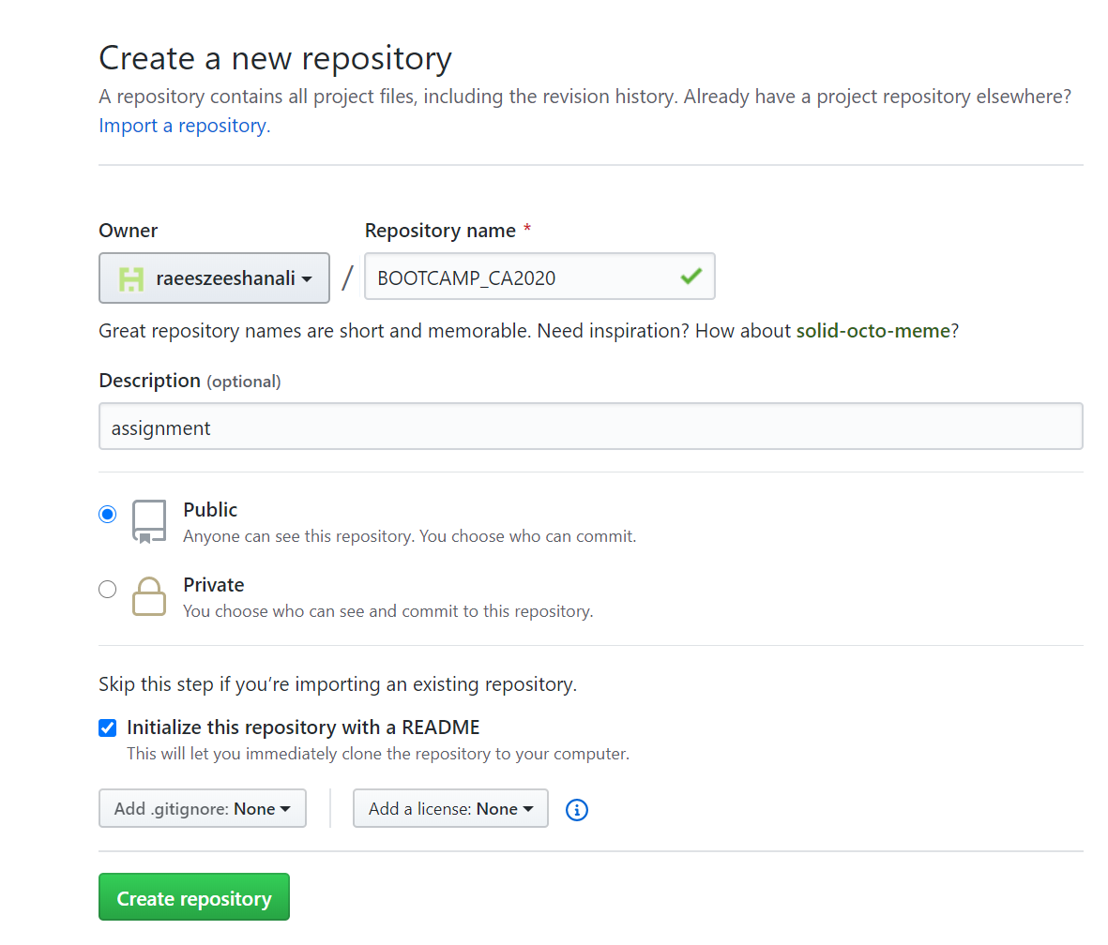

**TASK 03:**

* What is an Elastic IP and how it is different from Dynamic IP?

ELASTIC IP AND DYNAMIC IP

An Elastic address is a kind of static IP4 address. It is designed for cloud computing and with elastic IP you can find the failure of an instance by remapping the address to the another machine in your account.

1. Its has few restriction and freedom
2. Its availability is limited
3. Its is small as compare to dynamic ip
4. The owner if elastic ip has higher control

Dynamic IP:

The dynamic is the public ip which is available to almost every body. Its sells or share its parts to the public ip

1. The restrictions are different as compared to elastic IP
2. A lot primary and secondary data is available.
3. More sources are available
4. Lower control

* What is the Client Server Model, Explain in detail?

 is structure that partitions tasks or workloads between the providers of a resource or service, called server and service requesters, called client Often clients and servers communicate over a computer network on separate hardware, but both client and server may reside in the same system. A server host runs one or more server programs, which share their resources with clients. A client does not share any of its resources, but it requests content or service from a server. Clients, therefore, initiate communication sessions with servers, which await incoming requests. Examples of computer applications that use the client-server model are email network printing, and the web pages.